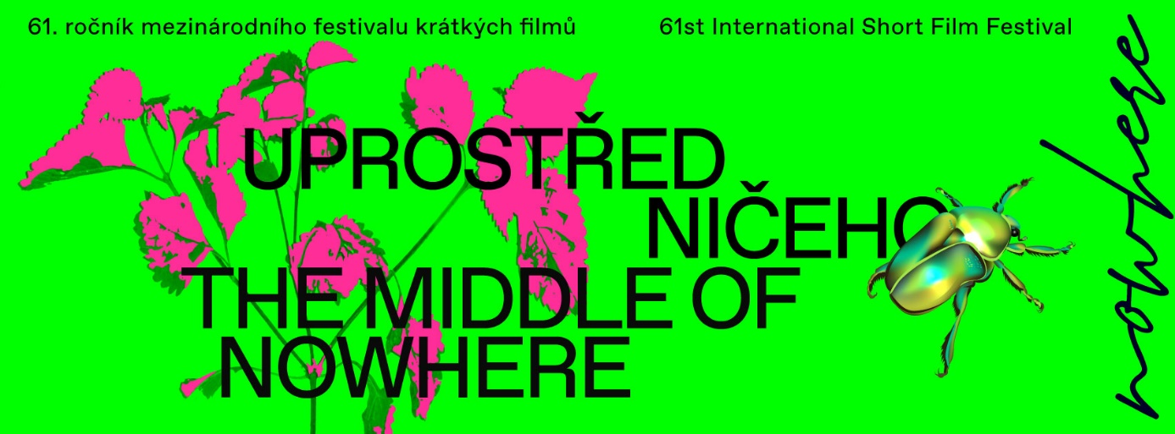
61st edition of the international short film festival BRNO16
Uprostřed ničeho / The Middle of Nowhere
2–6 December 2020

4 December 2020 / Brno
We know the winners of the 61st edition of the international short film festival BRNO16! The main award goes to the animated film Acid Rain. The festival will keep going until Sunday, 6 December. The audience can watch a selection from this edition of the festival on the Aerovod platform until the end of the year.

The international jury (Ondřej Pavlík, Marina D. Richter, Lee Adams, Tamás Gábeli a Krzysztof Sienkiewicz) chose the film Acid Rain by Tomek Popakul as the winner. The chair commented on the choice as follows: “A young couple meet, take drugs, go to a rave and suffer a terrifying comedown in Popakul’s astonishing hallucinatory animation. Acid Rain is awarded this year’s top prize because it takes the viewer on a complete psychedelic journey. The attention-grabbing animation technique creates a trance-like atmosphere while the sheer attention to detail is incredible, from the immersive sound design to the trippy dance number.” This is the director Tomek Popakul’s second festival win. In 2014 he already won the Visegrad Fund Award with his film Ziegenort. The main jury also awarded three special mentions to the films S P A C E S (Nora Štrbová), Such a Lovely Town (Marta Koch), and Exam (Sonia K. Hadad).

The Iranian film Exam was also chosen by the international student jury (Anastasia Ivanova, Zuzana Stanková, Filip Valíček, Stefan Veleski, and Jan-Karel Pavlík). The chair, Jan-Karel Pavlík, commented on the choice of the jury as follows: “By unanimous decision, we have chosen Exam by Sonia K. Hadad as the winner of The Student Jury Award. Exam uses the short film format to its full potential, gripping the audience right from the start and taking us through several levels of increasing suspense until the very end. The visceral nature of this short film, accentuated by its innovative cinematography and brilliant acting, transcends the cultural context that it so efficiently sets up and creates an immersive experience full of empathy and raw human emotion that the audience is unlikely to soon forget.”

The films submitted into the second edition of the competition for authors from the Czech Republic and Slovakia were also judged by an international jury (Anne Gaschütz, Lea Pagáčová, Vítězslav Chovanec). Anne Gaschütz comments on the choice of the winner by a directing duo Marta Prokopová and Michal Blašek, Wild Beasts, as follows: “Soothing water sounds, cracking wood and distant humming take us on a mysterious journey through a dark and atmospheric cosmos. With a love for detail, a distinctive sound design and a confident visual style, this film draws us into an imaginary world of night sweats, synchronized swimming and late-night campfires. Beautifully animated, we are immediately captivated by its strange and yet familiar creatures, disturbing narrative and alluring scenery. The Award of the Czechoslovak 16 Jury goes to Wild Beasts by Marta Prokopová and Michal Blaško.”

The audience award of the 61st edition of BRNO16 was decided via online voting forms. The award is going to The Depths by Ariane Louis-Seize.

“This edition of BRNO16 was challenging regarding its format. Fortunately, our team was prepared due to all the experiences we had collected in the past, and so we trust we managed to execute everything with our pride intact. Obviously, none of this would be possible without the amazing support from the director of our organization, Jana Janulíková and the support from the city of Brno,” commented the director of BRNO16, Milan Šimánek.

The 62nd edition of the international festival will take place on 13–16 October 2021.
The festival is organized by TIC BRNO, Public-benefit corporation, and specifically Kino Art and the TIC Gallery.
Further information: festival website: www.brno16.cz | festival Facebook: www.facebook.com/16brno/

Press contact:
Martina Marešová
tel.: 602 589 490
email: propagace@kinoart.cz

Festival staff:
Festival director: Milan Šimánek; selection of competition films: Jana Glocarová, Miloš Henkrich, Milan Šimánek

Patronage, funding, and partners:
The patron of the festival is the mayor of the Statutory City of Brno, Markéta Vaňková. The festival took place thanks to funding from the Statutory City of Brno, The Czech Film Fund, and the Ministry of Culture of the Czech Republic. We would like to extend our gratitude to all supporters and media partners.

